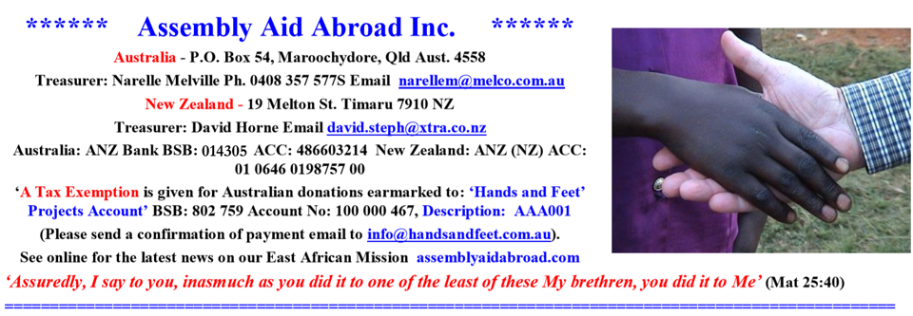
Acknowledgement – On behalf of the Assembly Aid Abroad committee we once again thank all our supporters in Australia and from New Zealand for their generosity with the overwhelming needs for the churches in Kenya, Uganda and Tanzania.
The hour is late, the night is coming when no one can work; and souls are held in the balance with the day of opportunity closing.
URGENT FAMINE RELIEF:

Food relief support from AAA for
Busia Region

Busia Brethren Assembly
Khunyanga Bretrhen Assembly
Chengo Brethren Assembly

Food relief support from AAA for Bungoma Region

Samoya Brethren Assembly
Siangwe Brethren Assembly
Misikhu Brethren Assembly
Lutungu Brethren Assembly
Mt. Elgon Brethren Assembly
Kimilili Brethren Assembly

Food relief support from AAA for Butere/Mumias Regions

Emusunguri Brethren Assembly
Ekero Brethren Assembly
Emukhuwa Brethren Assembly
SOME BUILDING PROJECTS IN WESTERN KENYA AND UGANDA SUPPORTED BY AAA
Khunyanga Brethren Assembly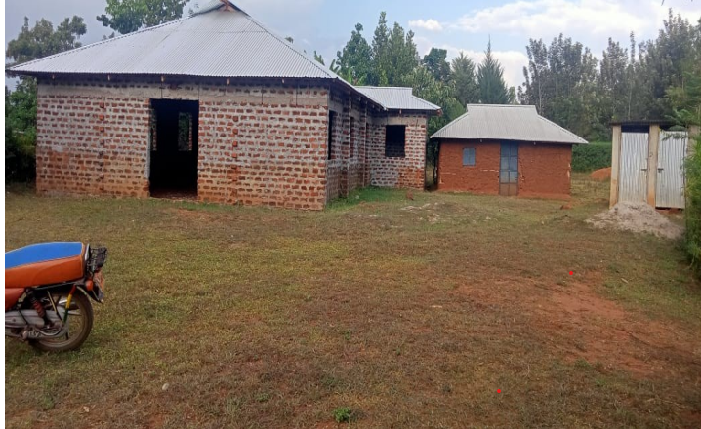
Busitema Brethren Assembly - Uganda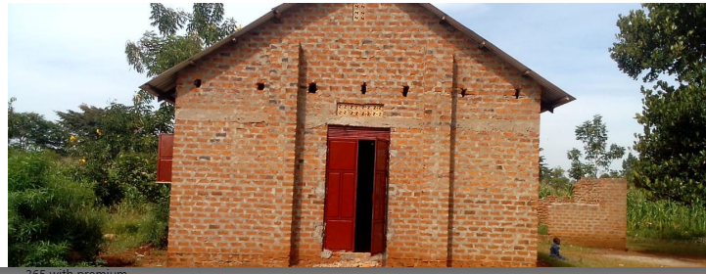
Emusunguri Brethren Assembly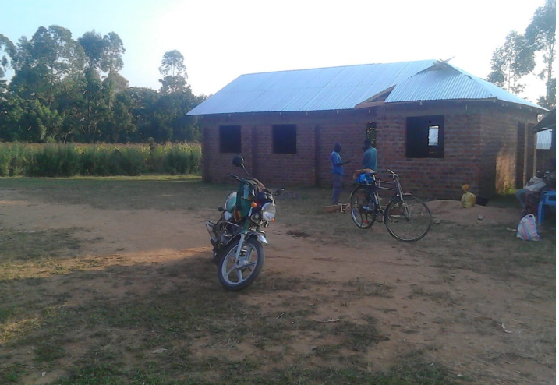
Mifumi Brethren Assembly - Uganda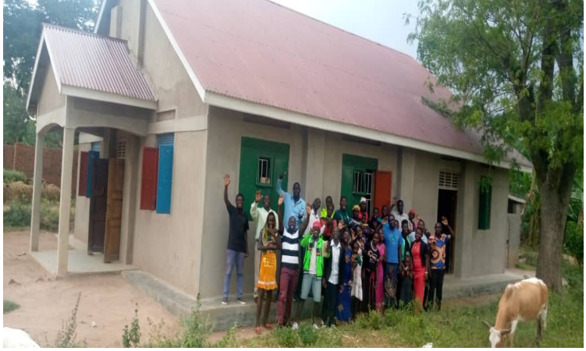
====================================Evans & Jane Akhwale – Uganda
Bible training school at Uganda.
Dear brother John Melvin, greetings! I hope you are fine in the Lord. Thank you so much for the support. We received and distributed. We had Bible Training Schools in Tororo and at Kayunga in Uganda as from 11/09/2023 to 16/09/2023. Immediately after Uganda, we had a Bible Training in Diploma of Theology with AUSTRALIAN COLLEGE OF CHRISTIAN STUDIES as from 18/09/2023 to 22/09/2023. From 02/10/2023, if God wills, I will be having prison ministry to 20/10/2023. Value your prayers. Afterwards, if God opens the way, I will be planning Kisii trip. Also we are preparing for BAF KENYA ANNUAL GENERAL MEETING as from 09/11/2023 to 10/11/2023. Otherwise I will update you about the Lord's work soon.
We are praying for you. God bless John, we understand the economic situation around the world. But we thank God for all that He has done. He has done great things that we cannot tell it all. Praise His name. We shall continue to trust and have faith in Him. Let's us pray for your journey to Kenya, youth camp and elders meeting in RONGO. Thanks for the support as a full time worker. I thank God for all brethren whom the Lord uses to support me in the ministry. May God bless their lives and meet them at the point of all their needs. I feel comforted in the Lord. It is because of these brethren who support me that I am able to serve the lord effectively. Last month of October we visited about 12 prisons in Nyanza and Riff Valley and about 1351 souls came to Christ and received Him as Lord and Savior. Praise be to God. Also we introduced these prisons to Emmaus Bible School to start doing Bible courses. Let's pray that God will bless His work. Jane and Evans Akhwale
Daniel Shiranda – Uganda

Bible training in Uganda.
Dear John, as from 15th to 24th, we travelled to four BAF churches in Uganda. We had good time ministering the word of God.
We were able to meet over 90 brethren in all the assemblies of which youths were high in number.
Over a hundred children were also reached especially on Sunday at Mifumi Tororo assembly.
This time I did witness the handing over of the bible training finances to church leaders in all the assemblies. Each assembly received support. The financial expenditure reports will be submitted to you through Brother Evans. Toilets are to be constructed at Busitema and Kayunga assemblies. John surrendered the Land to the name of the church before Ugandan authorities in the church. He also received support. Chairs were bought for Kayunga.
I am praying and planning to travel back to Uganda to strengthen them and also teach New Testament principles in each assembly Bible senimars in Uganda. I would love to visit and break bread with them. Please pray and consider my transportation. We arrived safely home yesterday on Thursday evening. Thanks so much for your prayers and financial support. Kindly find the attached photo of the ministry. Thanks Daniel.

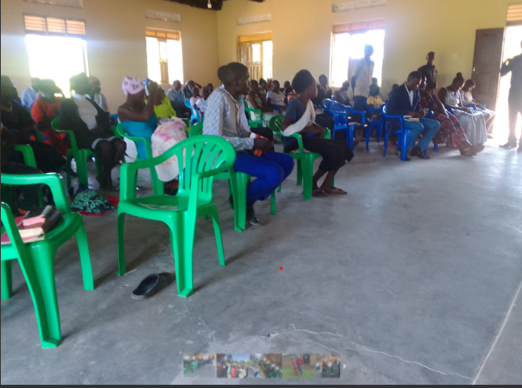

====================================
Daniel Shiranda – Kimillili, Western Province
53,000 students reached by the gospel of Jesus Christ. 100 students were baptized.
One church is to be planted soon at Mirere market as a result of evening film shows at the market centers. Thanks so much for your prayers and financial support. God bless you all.
Photos provided.
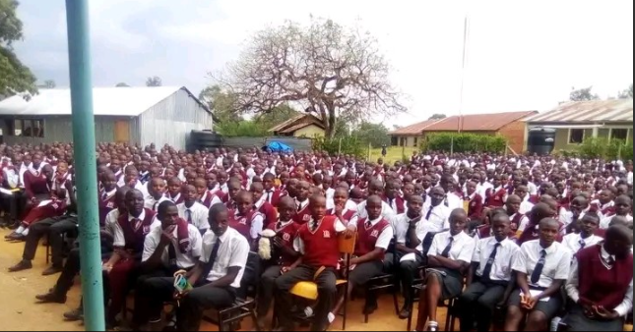

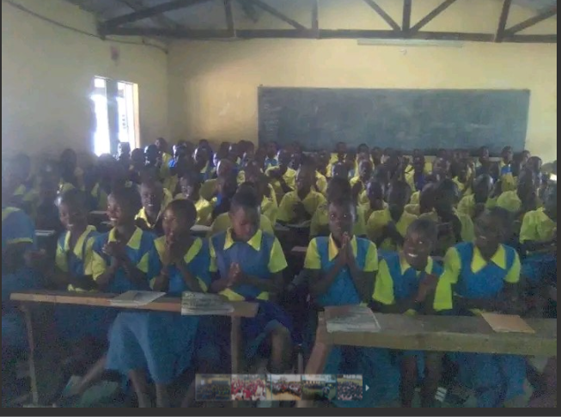

William Akoto – Tanzania

Dear John, Greetings in our Lords name, I hope you and family are in good health. We too are OK and doing well in the Lord. We held our monthly elders meeting last month and reports for good progress and steadfast fellowship was given from all the assemblies. We have been able to plant another 3 new assemblies, 2 in Tanzania and 1 in Kenya. We are praying to recommend 3 new elders to help in this new work, so help us pray for this new team. I have been doing leadership training and church planting seminars, and after 3 months, I'm asking if you can help send us some materials.
I'm also very grateful for the support given to my son, he qualified to join one of our national schools, a very best school. It really helped me a lot, may God bless those who felt touched by that need and gave.
Thank you and keep us in prayer.

This is Ikoma Assembly in Tanzania, this church has completed the walls but are not able to put up the roof, they're praying and asking for help for their chapel roof. Please consider them for prayer and support.

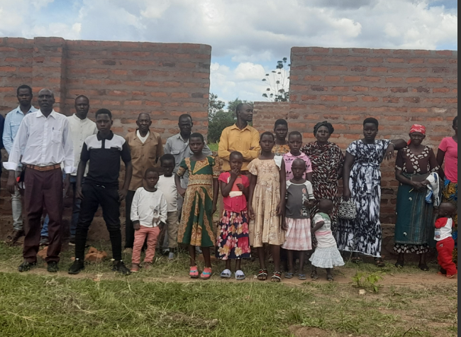

===================================
Linus Oluoch Otigo – Nyandiwa, Central Province)
REPORT BY LINUS OLUOCH OTIGO.
I thank the almighty God for His protection and care over the month of June. Again I want to thank Him for His grace in the church that I am taking care of the youth and children ministry over the month of June. Here is a breakdown of what is happening.

CHURCH MINISTRY:
I thank the almighty God for giving me this noble task of taking care of people in Nyandiwa Brethren Assembly. Nyandiwa assembly is located in a place where the majority of people in the village do not know God. This is because of alcohol and some drugs that have a very strong root in the area and so people do not have time to hear the word of God. When I realized that, I and some of the brothers started evangelism in that area though the assembly that was already there before. So in Nyandiwa assembly we are doing door to door evangelism, mid week fellowship and in every Sunday we break bread and engage in teaching the word of God. The Lord has been adding to our fellowship, faithful men and women every day.

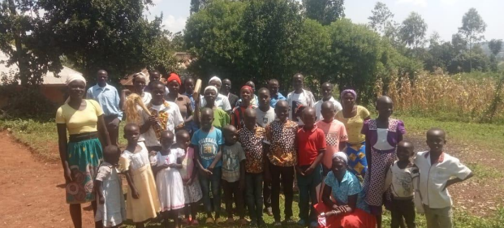

SCHOOL MINISTRY:
In school ministry, once again l thank the almighty God for allowing me to reach young people in high schools and also in colleges with the word of God. In this ministry I have three people who are willing to help me in this noble task. I thank God for them. In terms of reaching out to young ones in colleges and high schools our Lord is touching the hearts of teens in secondary schools and colleges and many of them are coming to Christ. Here is the breakdown in terms of outreach per week. We are reaching 16,785 students per week in ten schools while my brothers who are helping me are reaching 20,249. I do school ministry in lakeside region and some remote schools. Again we do discipleship and we do mentorship to students. Total reached 37,034 students. 762 students professed faith in Jesus Christ.

TESTIMOMY:
One of students from one of schools that I minister came to me last Wednesday and she testified that since she joined form one, one of her friends is in form three and invited her in a certain group in the school and since that day she is not as usual. Later she realized that her friend is a member of illuminati group, but she is now free, having given her life to Christ. l prayed with her and she now glorifies God for His help

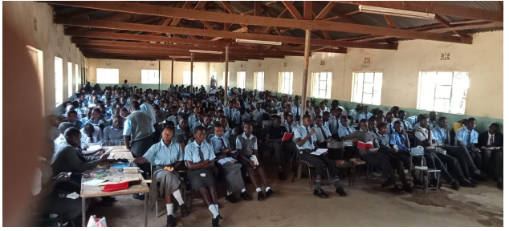

====================================
Nahashon Namale – Diani Beach: Mombasa

Sisters conference on the 1st August 2023 at Diani Beach
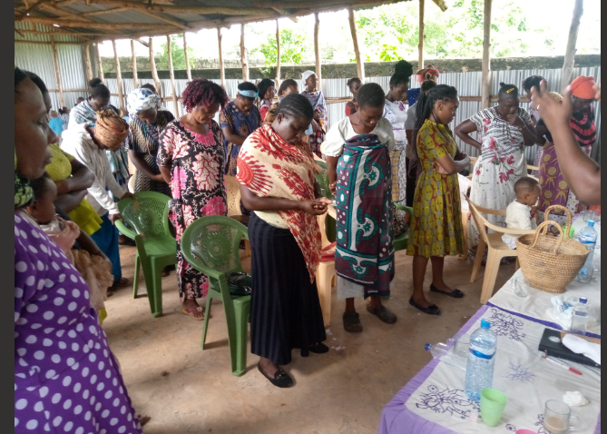

Did you know?
If you wish to give to the Lord’s work in Africa, you can direct your gift to a specific ministry (or ministries).
You just need to specify on the payment which ministry or ministries you would like your gift to be directed to. The ministries include:
Tax deductions earmarked with asterisk
- *Orphan sponsorship
- *Orphanage building grants
- *Widows’ housing
- *Self-supporting project grants for widows, orphans and gospel workers
- *High School Sponsorship (orphans and/or from poor families)
- *University Sponsorship (orphans and/or from poor families)
- *Medical assistance
- *Food and other relief measures
- Gospel worker support – housing
- Gospel worker support - expenses
- Subsidised Bibles / Hymn Books / Gospel literature
- Emmaus Bible Correspondence Courses
- Short-term Bible Schools (1-2 weeks)
- Church building construction
- Transport assistance (motorbikes, push bikes etc)
- Where most needed
AAA bank account details: Refer to top.
---------------------------------------------------------------
Committee Members:
President: Dr. Mel Heazlewood
Dept. President: John Denman
Consultant: John Melville –
johnm@melco.com.au
Treasurer: Narelle Melville
Secretary: Gary McCullock

Thank you for praying for this ministry
If any churches are interested in the work of Assembly Aid Abroad in Africa and North India and you would like a guest speaker to present a power point presentation please contact:
Dr. Mel Heazlewood
President
0409628433
Also find us on:
www.assemblyaidabroad.com

